**VISVESVARAYA TECHNOLOGICAL UNIVERSITY**

**“JNANA SANGAMA”, BELGAUM-590014, KARNATAKA**

###### A Project Phase-2 Report on

**“MANIPULATION OF COMPUTER SYSTEMS BY INTERPRETING BRAINWAVES”**

##### Submitted in partial fulfilment of the requirement for the award of degree of

**BACHELOR OF ENGINEERING**

#### In

**COMPUTER SCIENCE AND ENGINEERING**

##### Submitted By

**SANJAY P D 1AP17CS031**

**GANESH G 1AP17CS011**

**RAJKUMAR 1AP17CS028**

**VAIBHAV N SHASTRI 1AP17CS033**

Under the guidance of **Prof. Muniraju M** Assistant Professor, Dept. Of CSE, APSCE

**APS COLLEGE OF ENGINEERING DEPARTMENT OF COMPUTER SCIENCE AND ENGINEERING**

**Anantha Gnana Gangothri**

**26th k.m, N.H-209, Kanakapura Road, Bangalore-560 082 2020-2021**

**APS COLLEGE OF ENGINEERING**



###### (Affiliated to Visvesvaraya Technological University) Anantha Gnana Gangothri

###### 26th k.m, N.H-209, Kanakapura Road, Bangalore-560 082

**DEPARTMENT OF COMPUTER SCIENCE AND ENGINEERING**

***CERTIFICATE***

*Certified that the project work entitled*

**“MANIPULATION OF COMPUTER SYSTEMS BY INTERPRETING BRAINWAVES”**

*Is a bonafide work carried out by*

**SANJAY P D 1AP17CS031**

**GANESH G 1AP17CS011**

**RAJKUMAR 1AP17CS028**

**VAIBHAV N SHASTRI 1AP17CS033**

In partial fulfillment for the award of degree of Bachelor of Engineering in Computer Science & Engineering of Visvesvaraya Technological University, Belgaum during the academic year 2020-2021.

It is certified that all corrections/suggestions indicated for Internal Assessment have been incorporated in the report deposited in the departmental library. The project report has been approved as it satisfies the academic requirements in respect of project work prescribed for the Bachelor of Engineering Degree.

Signature of the Guide Signature of the HOD Signature of the Principal **Prof. Muniraju M Prof. Bhagyashree R Dr. Jagadeesh H S** Assistant Professor, Assistant Professor & Head, Principal,

Dept. Of CSE, APSCE Dept. Of CSE, APSCE APSCE

###### Name of the Examiners Signature with date 1.

###### 2.

**ACKNOWLEDGEMENT**

The satisfaction that accompanies the successful completion of any task would be incomplete without the mention of the people who made it possible, whose constant guidance and encouragement crowned are efforts with success.

We thank our Principal, **Dr. JAGADEESH H S**, A P S College of Engineering, for providing us with all the facilities that helped us to carry out the work easily.

We are greatly indebted to **Prof. BHAGYASHREE R**, Assistant Professor and Head, Department of Computer Science & Engineering for providing us with the best facilities and atmosphere for creative work, guidance and encouragement.

We are immensely grateful to our internal guide **Prof. MUNIRAJU M**, Assistant Professor, Department of Computer Science & Engineering for his insightful comments and for sharing his invaluable knowledge and experience with us. We really appreciate his help to improve the quality of the report.

We are immensely grateful to our project coordinator **Prof.** **SAMEERANA C P**, Assistant Professor, Department of Computer Science & Engineering for his guidance, encouragement and cooperation.

We would also like to thank all the teaching and non-teaching staff members of the Computer Science and Engineering Department for their support. We are very grateful to our parents and well-wishers for continuous moral support and encouragement.

**SANJAY P D 1AP17CS031**

**GANESH G 1AP17CS011**

**RAJKUMAR 1AP17CS028**

**VAIBHAV N SHASTRI 1AP17CS033**

**ABSTRACT**

A brain–computer interface, sometimes called a neural control interface, mind–machine interface, direct neural interface, or brain–machine interface, Over the past few areas the research in the field of brain interfaces, human-machine interfaces has taken a new rise but all these brain interfaces are designed on a few basic mechanism’s communication pathways between an enhanced or wired brain and an external device.

This type of mechanism would increase an individual’s independence, leading to an improved quality of life and reduced social costs. BCI research is a multidisciplinary field integrating researchers from neuroscience, physiology, psychology, engineering, computer science, rehabilitation, and other technical and health-care disciplines. As a result, there have been several varied approaches to the design of BCIs reported over the last three decades.

Rehabilitation based on brain-machine interfaces (BMI) has been shown as a feasible option for stroke patients with complete paralysis. However, the pathologic EEG activity after a stroke makes the detection of movement intentions in these patients challenging, especially in those with damages involving the motor cortex. Residual electromyography activity in those patients has been shown to be decodable, even in cases when the movement is not possible. Hybrid BMIs combining EEG and EMG activity have been recently proposed, although there is little evidence about how they work for completely paralyzed stroke patients. We show how EMG activities provide complementary information for detecting the movement intentions, being the accuracy of the hybrid BMI significantly.

Hence, this project is aimed at individuals who can benefit from using the BCI technology for day-to-day computer interactions, as it has a promising future towards helping people with disabilities and also helping people who use the computers extensively on a regular basis.

**TABLE OF CONTENTS**

1. INTRODUCTION 1
   1. Introduction to BCI 1
   2. About Brainwaves 2
   3. EMG and EEG 4
   4. Problem Statement 6
   5. Aim of Project 6
   6. Motivation 6
   7. Methodology 7
   8. Related Works 10
      1. Theory and Background 10
      2. Signal Processing 10
      3. Previous work 11
      4. Major Steps of Signal Processing 12
   9. Organization of the Report 15
2. LITERATURE SURVEY 16
3. SOFTWARE REQUIREMENTS SPECIFICATION 19
   1. System Overview 19
      1. Product Perspective 19
   2. System Requirements 20
      1. Software Requirements 20
      2. Hardware Requirements 20

**4** **HARDWARE REQUIREMENTS SPECIFICATION 21**

4.1 Hardware Overview 21

4.2 Powering of the Circuit 21

4.3 Hardware Equipment 21

4.3.1 Gelled EMG Electrode 21

4.3.2 Jumper wire 22

4.3.3 Dry EMG electrode 22

4.3.4 ECG pads 22

4.3.5 EMG sensor 22

4.3.6 NodeMCU (ESP8266 12E) 22

5 SYSTEM DESIGN 23

5.1 Introduction 23

5.1.1 Selection of platform 24

5.1.2 Selection of language 24

5.2 High level Design 25

5.3 Design Consideration 25

5.4 Process Flow chart 26

5.5 System Architecture 27

6 IMPLEMENTATION 29

6.1 Modules of Project 29

6.1.1 Amplification 30

6.1.2 Filtration 30

6.1.3 Feature Extraction 30

6.1.4 Software Trigger 31

7 TESTING 32

* 1. Test cases 32
  2. Module testing 32

8 RESULTS 36

9 CONCLUSION AND FUTURE SCOPE 37

9.1 Future Enhancements 37

10 REFERENCES 39

|  |  |  |
| --- | --- | --- |
| **FIGURE** | **FIGURE NAME** | **PAGE NO.** |
| **Fig. 1.1** | Brain waves Graph | 3 |
| **Fig. 1.2** | EMG Spectrum and noise influence on this spectrum | 5 |
| **Fig. 1.3** | Monitoring Brain waves | 8 |
| **Fig 1.4** | Steps of signal Processing | 12 |
| **Fig 1.5** | Monopolar signal acquisition | 13 |
| **Fig. 5.1** | Process flow diagram of BCI | 26 |
| **Fig. 5.2** | Steps of EMG Mechanism | 27 |
| **Fig. 5.3** | High pass filter | 28 |
| **Fig. 5.4** | Low pass filter | 28 |
| **Fig 5.5** | Band pass filter | 28 |
| **Fig. 7.1** | Test Image with Some Noise | 33 |
| **Fig. 7.2** | Subject is clenching fist | 34 |
| **Fig. 7.3** | Subject in rest with eyes opened | 35 |
|  |  |  |
|  |  |  |
|  |  |  |
|  |  |  |
|  |  |  |
|  |  |  |
|  |  |  |
|  |  |  |

|  |  |  |
| --- | --- | --- |
| **TABLE** | **TABLE NAME** | **PAGE NO.** |
| **Table 7.1** | Module test case for raw input in a still state without any action | 33 |
| **Table 7.2** | Module test case for eyes in closed state | 34 |
| **Table 7.3** | Module test case for eyes in open state | 35 |
|  |  |  |
|  |  |  |
|  |  |  |
|  |  |  |
|  |  |  |
|  |  |  |

**Chapter 1**

**INTRODUCTION**

## 

## 1.1 Introduction to BCI

The brain computer interface (BCI) is a system whereby one can control computer systems and external devices by voluntarily controlling brainwaves. Such a system can be used for controlling system events and external devices such as Iot devices and prosthetics. The response generated from the brain is measured and processed to trigger events on a computer systems or on an external device. Electroencephalography (EEG) is used to record brainwaves by means of a headset and a receiver.

There are many different techniques to measure brain signals.

We can divide them into Non-Invasive, Semi-invasive and Invasive.

|  |  |  |
| --- | --- | --- |
| **Non-invasive** | The sensors are placed on the scalp to measure the electrical potentials produced by the brain (EEG) or the magnetic field (MEG). |  |
| **Semi-invasive** | The electrodes are placed on the exposed surface of the brain (ECoG). |  |
| **Invasive** | The micro-electrodes are placed directly into the cortex, measuring the activity of a single neuron. |  |

**Non-invasive**: the EEG signal is taken placing electrodes on the scalp, so on the most external part.

**Semi-invasive**: the ECoG signal is taken from electrodes placed in the dura or in the arachnoid.

**Invasive**: The Intraparenchymal signal is taken directly implanting electrodes in the cortex. Invasive types of BCI are implanted directly into the brain during a neurosurgery. There are **single unit** BCIs, which detect the signal from a single area of brain cells, and **multiunit** BCIs which detect from multiple areas. Electrodes have different lengths, for example, up to 1.5 mm (Utah, Blackrock Microsystems) or

10 mm (FMA, Microprobes) in a MEA. The quality of the signal is the highest, but the procedure has several problematics, as for example the risk of forming scar tissues. The body reacts to the foreign object and builds the scar around the electrodes, which cause deterioration in the signal. Because neurosurgery can be a risky and expensive process, the target of invasive BCI are mainly blind and paralyzed patients.

**Semi-Invasive: ECoG**- Electrocorticography uses electrodes placed on the exposed surface of the brain to measure electrical activity from the cerebral cortex. It has been used for the first time in the 1950s at the Montreal Neurological Institute. It is called semi-invasive but it still requires a craniotomy to implant the electrodes. For this reason, it is used only when surgery is necessary for medical reasons (epilepsy for example).

The electrodes may be placed outside the dura mater (epidural) or under the dura mater (subdural). The strip or grid electrodes covers a large area of the cortex (from 4 to 256 electrodes), allowing a diverse range of cognitive studies.

## 1.2 About Brainwaves

The human brain consists of cells called neurons which communicate with each other to process information. This communication occurs by sending and receiving electrical signals, we can read these signals with the help of **electroencephalography technology (EEG),** which is the process of recording brain activity from the scalp using electrodes.

The different electrical frequencies found are as follows:

* **Gamma waves** are in the frequency range of 31Hz and up. It is thought that it reflects the mechanism of consciousness. Beta and gamma waves together have been associated with attention, perception, and cognition.
* **Beta waves** are in the frequency range of 12 and 30 Hz but are often divided into β1 and β2 to get a more specific range. The waves are small and fast, associated with focused

concentration, and best defined in central and frontal areas. When resisting or suppressing

movement, or solving a math task, there is an increase in beta activity.

* **Alpha waves,** ranging from 7.5 to 12 Hz, are slower and associated with relaxation and disengagement. Thinking of something peaceful with eyes closed should give an increase in alpha activity. Most profound in the back of the head (o1 and o2) and the frontal lobe.
* **Theta waves**, ranging from 3.5 to 7.5 Hz, are linked to inefficiency, daydreaming, and the very lowest waves of theta represent the fine line between being awake or in a sleep state. Theta arises from emotional stress, especially frustration or disappointment. It has also been associated with access to unconscious material, creative inspiration, and deep meditation. High levels of theta are considered abnormal in adults, and is, for instance, much related to AD/HD.
* **Delta waves**, ranging from 0.5 to 3.5 Hz, are the slowest waves and occurs when sleeping. If these waves occur in the awake state, are thought to indicate physical defects in the brain.

Movement can make artificial delta waves, but with an instant, this can be verified or unconfirmed.

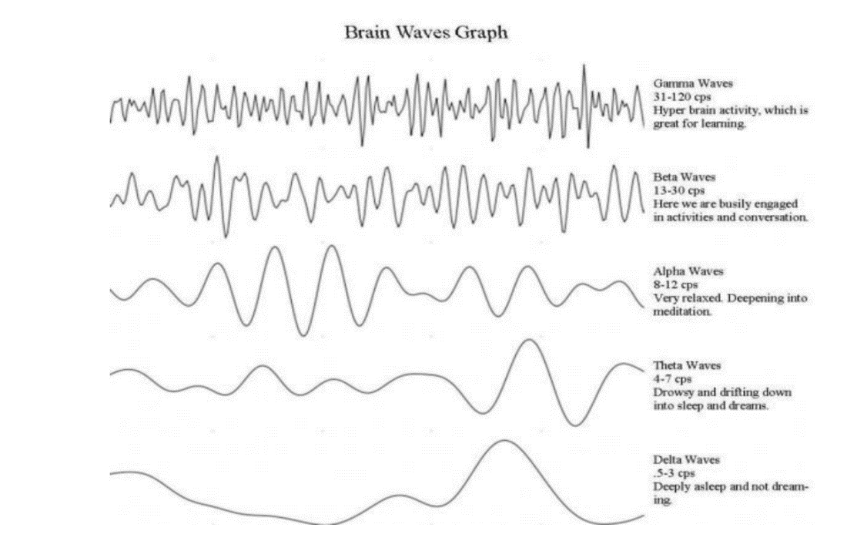

**Fig 1.1** Brain waves graph

**1.3 EMG and EEG**

Electromyography (EMG) is the subject which deals with the detection, analysis and utilization of electrical signals emanating from skeletal muscles. The field of electromyography is studied in Biomedical Engineering. And prosthesis using electromyography is achieved under Bio mechatronics. The electric signal produced during muscle activation, known as the myoelectric signal, is produced from small electrical currents generated by the exchange of ions across the muscle membranes and detected with the help of electrodes. Electromyography is used to evaluate and record the electrical activity produced by muscles of a human body. The instrument from which we obtain the EMG signal is known as electromyography and the resultant record obtained is known as electromyogram.

EEG based BCI devices were also implemented in powered wheelchairs, prosthesis and exoskeletons. However, EEG signals also suffers from several drawbacks such as low spatial resolution due to volume conduction and lower accuracy due to low signal to noise ratio. On the other hand, the EMG signals are frequently used to control prosthetic devices and exoskeletons. However, using EMG signal alone depends on the amount of residual muscle activity which is subject to fatigue, especially in case of older people and stroke patients. To overcome these drawbacks, different biological signals are also fused with the EEG signal for improved performance. In recent years several methods of fusing EEG and EMG signals have become popular to build hybrid BCI systems. Such hybrid BCI systems combines the features extracted from both EEG and EMG signals to detect the user’s movement intent.

Although the hybrid BCI approach is gradually becoming popular there are very few studies which deal with the bio-robotics applications. Studies have shown that the combined multimodal data from EEG and EMG enhances the movement intention prediction rate with increased reliability. Leebet al has also shown that the fusion of EEG and EMG signals resulted in higher accuracy than solely using either signal in generating neurofeedback.

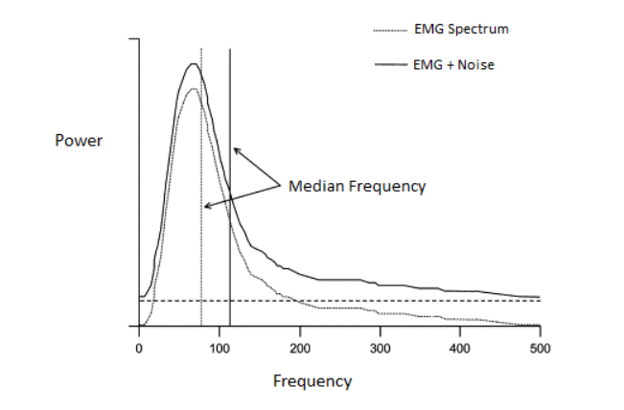

**Fig 1.2** EMG Spectrum and noise influence on this spectrum

The EMG signal’s amplitude lies in between 1-10 mV, making it a considerably weak signal. The signal lies in the frequency range from 0-500 Hz and most dominant in between 50-150 Hz.

The EMG signal is highly influenced by noise. The characteristics of electrical noise can be caused from various sources. Ambient noise can be caused by electromagnetic radiation sources e.g. radio transmission devices, fluorescent lights and power line interference from electrical wires. These interferences are almost impossible to avoid from external means. This particular noise exists in the frequency range of 50-60 Hz. Noise can also be generated from motion artifact. The two main sources of this noise are instability of electrode skin interface and movement of the electrode cable and lies mostly in the range of 0-20 Hz. It can be eliminated by proper set of EMG equipment and circuitry. The maximum fidelity of the signal is determined by the acquired EMG signal-to-noise ratio

## 

## 1.4 Problem Statement

The Traditional computer systems use physical input devices that require the user to move the input device to interact with them. A new type of input device that uses the electrical activity of the brain can be used as an input device for controlling computer systems and appliances. This enables normal users an extra depth of usability and also enables disabled people to use computer systems more naturally.

**1.5 Aim of the Project**

The ultimate goal of this project is to create a specialized interface that will allow an individual to control everyday devices such as computers, phones, tablets, Iot devices by thought and individuals with severe motor disabilities to have effective control of devices such as computers.

**1.6 Motivation**

Brain computer interface (BCI) systems build a communication bridge between human brain and the external world eliminating the need for typical information delivery methods. They manage the sending of messages from human brains and decoding their silent thoughts. Thus they can help handicapped people to tell and write down their opinions and ideas via variety of methods such as in spelling applications, semantic categorization, or silent speech communication. BCIs can also facilitate hands-free applications bringing the ease and comfort to human beings through mind-controlling of machines. They only require incorporating brain signals in order to accomplish a set of commands and no muscles intervention is needed.

Early BCI applications have targeted disabled users who have mobility or speaking issues. Their aim was to provide an alternative communication channel for those users. But later on, BCI enters the world of healthy people as well. It works as a physiological measuring tool that retrieves and uses information about an individual’s emotional, cognitive or effectiveness state. The target of brain signals utilization has been extended beyond controlling some object or offering a substitution for specific functions, in what is called passive BCI.

Brain-computer interface (BCI) technology represents a highly growing field of research with application systems. Its contributions in medical fields ranging from prevention to neuronal rehabilitation for serious injuries.

BCIs use electroencephalography (EEG) technology for reading brainwaves, the use of this technology is to diagnose brain disorders, especially epilepsy or any other seizure disorders. People can learn to control mu (8-12 Hz) or beta (18-25 Hz) rhythm amplitude in the electroencephalogram (EEG) recorded over sensorimotor cortex and use it to move a cursor to a target on a video screen. The recorded signal may also contain electromyogram (EMG) and other non-EEG artifacts. This study examines the presence and characteristics of EMG contamination during new users' initial brain-computer interface (BCI) training sessions, as they first attempt to acquire control over mu or beta rhythm amplitude and to use that control to move a cursor to a target.

## 1.7 Methodology

* The Brainwaves are read using an EEG headset which records the data preprocesses it by taking difference between the potentials of the ground and electrode or between adjacent electrodes with reference to ground electrode which is connected to the ear as neutral or reference electrode.
* The brain signals have a low amplitude of 10-200 microvolts and hence need to be amplified to a desirable voltage which can be detected by other components and microcontrollers. After amplification, we filter the signal for a specific type of brainwave (alpha, beta, gamma, theta, delta)
* In order to use these signals for triggering any type of event we monitor the signal for patterns which occur when an action is performed or is thought.
* Exposure to external stimuli, such as a tone or light flash, can generate responses in the EEG wave. Internal stimuli, like skipping an expected stimulus can also generate a response. In both cases this is called Event Related Potentials (ERP), or Evoked Potential (EP). What this means exactly is that there is an observable amplitude peak (potential) that occurs at a definite latency

time after the specific stimuli.

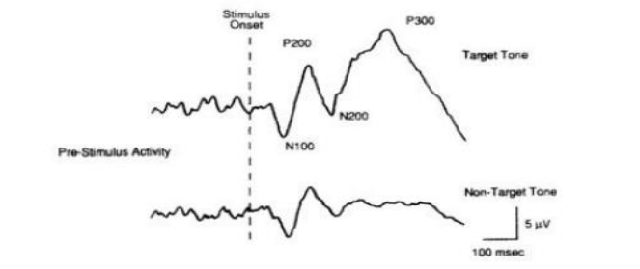

**Fig 1.3** Monitoring Brain waves

The movement of the human body is possible through muscles in coordination with the brain. Whenever the muscles of the body are to be recruited for a certain activity, the brain sends excitation signals through the Central Nervous System (CNS). Muscles are innervated in groups called ‘Motor Units’. A motor unit is the junction point where the motor neuron and the muscle fibers meet. A depiction of the Motor Unit. When the motor unit is activated, it produces a ‘Motor Unit Action Potential’ (MUAP).

The activation from the Central Nervous System is repeated continuously for as long as the muscle is required to generate force. This continued activation produces motor unit action potential trains. The trains from concurrently active motor units superimpose to produce the resultant EMG signal. A group of muscles are involved in a certain movement of the human body. The number of muscles recruited depends upon the activity in which the body is involved. E.g. in lifting a small weight such as a tiny pebble, fewer amount of muscles will be involved as compared to lifting a heavy mass like a 6 kg weight, where the muscles employed will be greater. In technical terms, whenever it is required to generate

greater force, the excitation from the Central Nervous System increases, more motor units are activated and the firing rate of all the motor units increase resulting in high EMG signal amplitudes.

Electromyography enables us to generate force, create movements and allow us to do countless other functions through which we can interact with the world around us. The electromyograph is a bioelectric signal which has, over the years, developed a vast range of applications. Clinically, electromyography is being used as diagnostic tool for neurological disorders.

## 

## 1.8 Related Works

### 1.8.1 Theory and Background

Our brains are filled with cells called neurons. Every time we think, move, feel or remember something, our neurons are at work. That work is carried out by biochemical and electric signals. Scientists can detect those signals and interpret what they mean by using electroencephalography (EEG) technology. EEG can read signals from the human brain and send them to amplifiers. The amplified signals are then interpreted by a BCI computer program which uses the signals to control a device.

EEG-based BCI are characterized by the technique of using non-invasive EEG electrodes to measure brain activity and translate the recorded brain signals into commands.

BCIs detect changes in brain activity measured through an EEG. BCI technologies then relay these signals to machine learning algorithms. The machine learning algorithms have been trained to pick up on EEG brain activity associated with certain emotions, actions and expressions. When the algorithms identify matching EEG brain activity, the BCI can transmit external commands to control a device (such as a computer cursor, robotic arm or wheelchair). The devices have been programmed to interpret and carry out these commands, whether controlling a physical object or a digital interface. A subject wearing an EEG device can think “move left” and the cursor moves to the left—that’s an example of an external action conducted on a digital interface. A subject using EEG based BCI that’s connected to a robotic arm can think “wave” and the robotic arm will wave.

### 1.8.2 Signal Processing

During any sort of thought/thinking process the human brain produces charged ions which become electrical signals, these signals are also the ones that are responsible for the entire functioning of the human body either voluntary or involuntary in nature. To control a computer, detection of the electrical signals from the brain is essential. Once detected, the brain signals need to amplify and then be sent to software to interpret them into corresponding computer action. The most common and reasonable technology used to monitor the electrical signal of the brain is Electroencephalogram (EEG). EEG is typically used by neurologists and is the simplest way to record the brain's electrical output.

EEG in many cases has its own device designed to record and process it for graphing and classification.

A BCI software is used to collect the electrical signal passed by the brain. This software is used to make machine learning (ML) algorithms and trained to recognize EEG readings related to any emotion or action. Once the algorithm tags with the EEG data, the BCI software carries the corresponding commands to control the computer; with this process, one can quickly move the computer's cursor to either right or left simply by thinking about moving the cursor right or left.

The EMG electrode placement has been elaborately explained under the previous heading. So, after properly understanding the target muscle profile, preparing the skin and positioning the EMG detecting surfaces, comes the EMG signal acquisition step.

EMG signal is acquired through differential amplification technique. The differential amplifier should have high input impedance and very low output impedance. Ideally, a differential amplifier has infinite input and zero output impedance.

Differential amplification is achieved with the help of an instrumentation amplifier for high input impedance.

### 1.8.3 Previous Works

The goal of PlayStation project was to meet some of the challenges that people with Attention Deficit and Hyperactive Disorder (AD/HD) have regarding the use of neurofeedback as a treatment option. The electroencephalography laboratory (EEGlab) at the Department of Psychology at NTNU, BUP (outpatients’ clinic for children) and St. Olavs Hospital, have a co-operative venture where neurofeedback is used when there is suspicion of such disorder or learning disabilities in children. They were interested in exploring a different approach to the usage of this technology; making neurofeedback training more attractive, reducing the training and equipment expenses and making it more fun and available to the public. The proposed method was to combine neurofeedback training with playing video games on a PlayStation. The result was a system with the ability to use clinical approved EEG equipment to control the acceleration of a racing car in a video game, both on PC and PlayStation, in conclusion, this made it possible to consider a more entertaining way of performing neurotherapy and prompted for a field study to map the potential for further investment (Larsen, 2010).

The PlayStation project builds on work done by Andersen, Juvik, Kjellen, and Storstein (2009), as part of a multidisciplinary course at NTNU. On initiative from Egil Tjaland and in cooperation with Stig

Hollup at Department of Psychology, ˚ their assignment was to steer a radio-controlled helicopter using the principles of neurofeedback. With their solution they were able to adjust the speed of the rotor using the level of concentration in a test person, and lift it off the ground. They developed an application that interfaced EEG software with the radio controller software of the helicopter.

Another works of EMG includes - Validation of a Low-Cost Electromyography (EMG) System via a Commercial and Accurate EMG Device: Pilot Study where the evaluation was done by means of a set of experiments, in which volunteers performed isometric and dynamic exercises while EMG signals from the rectus femoris muscle were registered by both the proposed low-cost system and a commercial system simultaneously. Analysis and assessment of three indicators to estimate the similarity between both signals were developed. These indicated a very good result, with spearman’s correlation averaging above 0.60, the energy ratio close to the 80% and the linear correlation coefficient approximating 100%. The agreement between both systems (custom and commercial) is excellent, although there are also some limitations, such as the delay of the signal (<1 s) and noise due to the hardware and assembly in the proposed system

**1.8.4 Major Steps of Signal Processing**

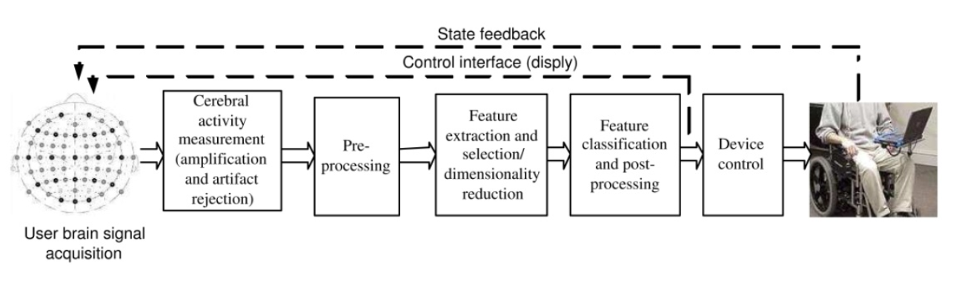

**Fig 1.4** Steps of Signal processing

### 1.8.4.1 Signal acquisition module

The Signal Acquisition Module is liable for recording the electrophysiological signals that provide input to the BCI. These signals are recorded from the scalp or from the surface of the brain or neuronal activity. BCI might use either invasive methods or non-invasive methods for signal acquisition. Invasive methods are electrocardiograms (ECoG) and single-neuron recordings and have better signal quality as compared to non-invasive methods. Non-invasive methods are Electroencephalogram (EEG), Magnetoencephalogram (MEG), Positron Emission Tomography (PET), Functional Magnetic Resonance Imaging (fMRI) and Near-Infrared Spectroscopy (NIRs).

The acquired signals are amplified to enhance the strength and are digitized before they are used by any of the computer application.

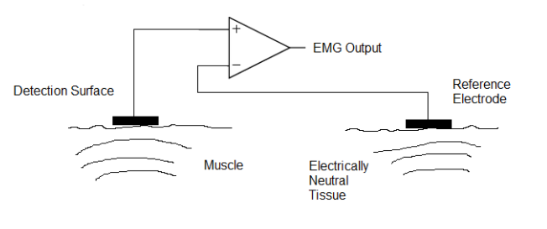

**Fig 1.5** Monopolar Signal acquisition

**1.8.4.2 Preprocessing**

The task of preprocessing is to prepare the recorded signals for processing by enhancing the signal –to- noise ratio (SNR). The part of EMG signal that comes from muscular activity of head, and eye movement generate electrical activity that is unrelated to the brain. Such part of signal is considered as artifact and should not be processed in order to preserve and exhibit the relevant information; therefore, preprocessing is done to remove artifacts in EMG signals. In BCI research, the proper preprocessing of EmG signal is important in order to obtain high classification accuracy. Preprocessing of BCI is based on the Covariance Matrix Adaptation Evolution Strategy (CMA-ES) which obtains the spatial and frequency selection filters automatically.

#### **1.8.4.3 Feature extraction**

After preprocessing the signal is fed into one or more type of feature extraction algorithms. This component extracts features in the time domain and frequency domain that encode messages or commands. Wide varieties of feature extraction methods are used in BCI system; some of these methods include amplitude measures, band power, Hjorth parameters, autoregressive models, and wavelets and spatial filters.

#### **1.8.4.4 Feature Classification or Post Processing**

The task of the classification component is to translate the features provided by the feature extractor to a category of brain patterns; that is the independent variable is converted into the dependent variable. The classification algorithms may use linear methods like Linear Discriminant Analysis (LDA) and Support Vector Machine (SVM) or non-linear methods such as neural networks.

### 1.8.4.5 Application module

For most current BCIs, the output device is a computer screen and the output is the selection of targets, letters, or icons presented on it. Some BCIs provide an output, such as cursor movement toward the item prior to its selection.

The output generated by the output device is the feedback provided to the user to notify the user about the recognized brain activity pattern. This pattern is then used to sustain and enhance the accuracy and speed of communication.

**1.9 Organization of the Report**

* + - **Chapter-1:** **Introduction-** This chapter tells about the introduction to brain control interface, problem statement, Aim of the project and motivation factors.
    - **Chapter-2: Literature Survey-** This chapter majorly deals with existing systems and proposed systems and related research works.
    - **Chapter-3: Requirement Specification-** This chapter speaks about the product perspective, user characteristics, its assumptions and dependencies, specific requirements, non- functional requirements and functional requirements.
    - **Chapter-4:** **System Design-** This chapter deals with the advanced software engineering where the entire flow of the project is represented by a professional data flow diagram

starting from level 0 till 3. This chapter mainly deals with use case diagram for the project representation

* + - **Chapter-5**: **Implementation-** This chapter deals with the steps involved in the creation of the project work. It is defined with the assistant of code explanation for the ease of reader.
    - **Chapter-6:** **Testing-** This chapter mainly deals with the various types of the test cases to prove the validity of the project.
    - **Chapter-7**: **Snapshots-** This chapter mainly deals with the output of the application.
    - **Chapter-8:** **Conclusion and Future Work-** This chapter is mainly the summary of the entire project development and it also suggests some of the enhancement ideas which couldn’t be covered up due to constraint of time and resources.
    - **Chapter-9: References-** This section mainly highlights all the journal and IEEE papers being referred for the development of the project.

**Chapter 2**

**LITERATURE SURVEY**

Recently, there have been many instances where brain activities have been taken into the computer science field. One main way of implementing this interface is using the BCI Libraries that have been developed and openly available to all research personnel to experiment with and come up with multiple new technology. Many such researchers have put in their efforts to improve this field and have provided their valuable work for newer research teams to develop it further. This has helped many to understand the important aspects of the brain functions and how it can be implemented into the computer field.

**1.“A General Framework for Brain–Computer Interface Design by Steven G. Mason, Member, IEEE, and Gary E. Birch, Member, IEEE.”**

The Brain–Computer Interface (BCI) research community has acknowledged that researchers are experiencing difficulties when they try to compare the BCI techniques described in the literature. In response to this situation, the community has stressed the need for objective methods to compare BCI technologies. Suggested improvements have included the development and use of benchmark applications and standard data sets. This paper proposes a new functional model for BCI System design. The model supports many features that facilitate the comparison of BCI technologies with other BCI and non-BCI user interface technologies. From this model, taxonomy for BCI System design is developed. Together the model and taxonomy are considered a general framework for BCI System design.

**2.“Classification of EEG Signals in a Brain Computer Interface System by Erik Andreas Larsen.”**

This report outlines the step-by-step implementation and testing for this system, and the result is a functional prototype that can use user EEG to control the snake in the game with over 90% accuracy. Two mental tasks have been used to separate between turning the snake left or right, baseline (thinking nothing in particular) and mental counting. The solution differentiates from other appliances of the neuroscience mindset that it does not require any pre-training for the user, and it is only partially real-time.

**3.“Brain Computer Interface-Controlling Devices Utilizing the Alpha Brain Waves by Rohan Hundia.”**

This paper describes the development and testing of an interface system whereby one can control external devices by voluntarily controlling alpha waves, that is through eye movement. Such a system may be used for the control of prosthetics, robotic arms and external devices like wheelchairs using the alpha brain waves and the Mu rhythm.

**4.“Wav2vec: Unsupervised Pre-Training for Speech Recognition by Steffen Schneider, Alexei Baevski, Ronan Collobert, Michael Auli Facebook AI Research”**

Unsupervised pre-training for speech recognition by learning representations of raw audio. wav2vec is trained on large amounts of unlabeled audio data and the resulting representations are then used to improve acoustic model training. We pre-train a simple multi-layer convolutional neural network optimized via a noise contrastive binary classification task. Our experiments on WSJ reduce WER of a strong character-based log-Mel filter bank baseline by up to 36 % when only a few hours of transcribed data are available. Our approach achieves 2.43 % WER on the nov92 test set. This outperforms Deep Speech 2, the best reported character-based system in the literature while using two orders of magnitude less labeled training data.

**5. Unsupervised feature learning for audio classification using convolutional deep belief networks by Honglak Lee Yan Largman Peter Pham Andrew Y. Ng Computer Science Department Stanford University Stanford, CA 94305**

Deep-learning approaches have gained significant interest as a way of building hierarchical representations from unlabelled data. However, to our knowledge, these deep learning approaches have not been extensively studied for auditory data. In this paper, we apply convolutional deep belief networks to audio data and empirically evaluate them on various audio classification tasks. In the case of speech data, we show that the learned features correspond to phones/phonemes. In addition, our feature representations learned from unlabelled audio data show very good performance for multiple audio classification tasks. We hope that this paper will inspire more research on deep learning approaches applied to a wide range of audio recognition tasks.

**6. Muhammad Zahak Jamal (October 17th 2012). Signal Acquisition Using Surface EMG and Circuit Design Considerations for Robotic Prosthesis, Computational Intelligence in Electromyography Analysis - A Perspective on Current Applications and Future Challenges, Ganesh R. Naik**

The major challenges faced in prosthetics are: electromechanical implementation, use of EMG control signals and the interface between robotic and clinical communities. Designing a robotic mechanism which is fully capable of integrating with human neuromuscular system is a tough proposition. The requirements can only be fulfilled if the apparatus is of light and flexible material with small but powerful actuators, size effective electronic components, sensors which can easily adapt with the skin and a long lasting battery life. Only then the machine will qualify to be used in everyday practical life.

**Chapter 3**

**SOFTWARE REQUIREMENT SPECIFICATION**

The following document details the requirements for the Management System for Distributed Environment. The software requirements shall be specified for all the phases of the Management System. The purpose of this Software Requirement Specification (SRS) Document is to specify the user goals and tasks that need to be achieved. SRS forms the basis of software development. Software Requirement Specification acts as a reference for validation of the final product. It helps to check if the software has met the requirements. Hence a high-quality SRS is a prerequisite to high quality software. Here, the chapter gives an overview on the following information:

1. System Overview.

2. Specific Requirements.

3. System requirements.

**3.1 System Overview**

1. **Purpose:** The purpose of proposed project is to enable disabled people use computer systems more fluently and enable people without any ailments to access computer systems with a new level of control and also to develop a neural network that can interpret brainwaves and associate it function.
2. **Input:** The input is electrical signal generated by nerve cells when they transmit signals from brain to rest of the body, which is then amplified and filtered.
3. **Output:** To trigger events on a computer such as clicking of a mouse, movement of cursor, simulate a button press, etc.

**3.1.1 Product perspective**

The proposed system can be used in Windows, Linux or MAC operating systems and is developed in python. The current framework uses python code to analyze frame rate it act as an interconnect between the devices and the systems. Finally, the product is used to enhance the ability to interact with the

computer systems without manual interventions which will be beneficial for the disabled people and it can also be used for other factors for manipulating devices and computer system for the practical use.

**3.2 System Requirements**

**3.2.1 Software Requirements**

* Operating system: Windows 7, 8, 10 | Linux | Mac OS 10.x
* Compiler/Interpreter: Python/Java
* Software IDE: PyCharm, IntelliJ IDEA, Arduino IDE

**3.2.2 Hardware Requirements**

* Processor: A dual-core CPU with 2.00 GHz base clock or better.
* Memory: 4GB or more.
* Storage: 10GB or more.
* Input Devices: Keyboard, Mouse, and compatible devices.

**Chapter 4**

**HARDWARE REQUIREMENTS SPECIFICATION**

**4.1 Hardware Overview**

A major issue and the problems that one comes across is the low amplitude of these brain signals. The brain waves have extremely low amplitude ranging from 10-200 microvolts; there for a high amount of amplification is required. The various stages of the setup. Coming up to the first stage

* **Amplification-** The brain signals have low amplitude of 10-200 microvolts and hence need to be amplified to a desirable voltage which can be detected by other components and microcontroller
* **Filtration**- The acquired signals that were captured using electrodes not only consisted of the brain waves component but it also consisted of the external noise ranging from around 45-65 Hz. In order to read EEG signals we are using an open-source project which has provided designs for a device to read, amplify, filter and transmit the EEG signals to a computer.

**4.2 Powering the circuit**

The circuit has three power rails, labelled as 5 V, Vref and GND. 5 V is from the 5 V pin of the Nucleo which is regulated, Vref is the reference voltage for the EEG signal being measured and is the voltage the user’s body will be held at. Vref is 1.5 V from a MIC37100-1.5WS voltage regulator. GND is the GND pin on the Nucleo. 1.5 V was chosen as the signal reference as it is close to the mid-range input voltage of the 3.3 V ADC. The ADC is the A0 pin on the microcontroller. The whole circuit is powered by a 9 V battery connected to the microcontrollers. Current consumption was not a major concern when designing the circuit.

**4.3 Hardware Equipment’s**

**4.3.1 Gelled EMG Electrodes**

Gelled EMG electrodes contain a gelled electrolytic substance as an interface between skin and electrodes. Oxidation and reduction reactions take place at the metal electrode junction. Silver – silver chloride (Ag-AgCl) is the most common composite for the metallic part of gelled electrodes. The AgCl layer allows current from the muscle to pass more freely across the junction between the

electrolyte and the electrode. This introduces less electrical noise into the measurement, as compared with equivalent metallic electrodes (e.g. Ag). Due to this fact, Ag-AgCl electrodes are used in over 80% of surface EMG applications.

**4.3.2 Jumper wire**

Jumper wires are simply wires that have connector pins at each end, allowing them to be used to connect two points to each other without soldering. Jumper wires are typically used with breadboard and other prototyping tools in order to make it easy to change a circuit as needed.

**4.3.3 Dry EMG electrodes**

Dry EMG electrodes do not require a gel interface between skin and the detecting surface. Bar electrodes and array electrodes are examples of dry electrodes. These electrodes may contain more than one detecting surface. In many examples, an in-house pre-amplification circuitry may also be employed in these electrodes. Dry electrodes are usually heavier (>20g) as compared to gelled electrodes (<1g). This increased inertial mass can cause problems for electrode fixation; therefore, a material for stability of the electrode with the skin is required.

**4.3.4 ECG pads**

An ECG pad is a small device that is placed on the body to detect the electrical activity of the heart. They are placed on the body and connected to wires (leads) that lead into an ECG machine (electrocardiograph), which displays the information on a bedside monitor and/or prints it.

**4.3.5 EMG sensor**

Electromyography (EMG) sensor is an electro diagnostic medicine technique for evaluating and recording the electrical activity produced by skeletal muscles. These EMG signals are used in many clinical and biomedical applications.

The Advance Technologies EMG Muscle Sensor V3.0 With Cable and Electrodes will measure the filtered and rectified electrical activity of a muscle; outputting 0-Vs Volts depending the amount of activity in the selected muscle, where Vs signifies the voltage of the power source. Power supply voltage: min. +-3.5V.

**4.3.6 NodeMCU (ESP8266 12E)**

Esp-12E Esp8266 Wifi Module is a low power consumption of the UART-Wifi module and ultra-low power consumption technology, designed especially for mobile devices and IoT applications, user’s

**Chapter 5**

**SYSTEM DESIGN**

## 5.1 Introduction

The following chapter gives overall flow of the project used in the design. Implementation is a stage in software development where the software design is realized as a set of program units. The objects that are identified in the design stage are implemented, and a function which manipulates these objects is realized.

In this phase, the system or system modifications are installed and made operational in a productive environment. Activities in this phase include notification of implementation to end users, execution of the previously defined training plan, data entry or conversion and post implementation review. This phase continues until the system is operating in production accordance with the defined user requirement. Successful implementation may not guarantee improvement but it will prevent improper installation. They are following four formalities:

* + - Careful Planning.
    - Investigation of the system and constraints.
    - Design the methods to achieve the changes.
    - Training the staff in the changed phase.

Implementation of any software is always preceded by important decisions regarding selection of the platform, the language used, etc. these decisions are often influenced by several factors such as the real environment in which the system works, the speed that is required, the security concerns, and other implementation specific details. There are three major implementation decisions that have been made before the implementation of the proposed project. They are:

1. Selection of platform (Operating System).
2. Selection of programming language for development of application.
3. Details of the flowchart and algorithms used in the proposed project.

### 5.1.1 Selection of Platform

Windows 7 and above version introduced several new features to the Windows line, including:

* + - * Fast user switching, which allows a user to save the current state and open applications of their desktop and allow another user to log on without losing that information.
      * Faster start-up and hibernation sequences.
      * The ability to discard a newer device driver in favor of the previous one (known as driver rollback), should a driver upgrade not produce desirable results.
      * A new, arguably more user-friendly interface, including the framework for developing themes for the desktop environment.

### 5.1.2 Selection of Language

Python is a general-use high-level programming language that bills itself as powerful, fast, friendly, open, and easy to learn. Python “plays well with others” and “runs everywhere” (according to the language’s About page). Its high-level built in data structures, combined with dynamic typing and dynamic binding, make it very attractive for Rapid Application Development, as well as for use as a scripting or glue language to connect existing components together.

Rather than having all of its functionality built into its core, Python was designed to be highly extensible. This compact modularity has made it particularly popular as a means of adding programmable interfaces to existing applications. Van Rossum's vision of a small core language with a large standard library and easily extensible interpreter stemmed from his frustrations with ABC, which espoused the opposite approach.

Python's large standard library, commonly cited as one of its greatest strengths, provides tools suited to many tasks.

Some of the powerful statistical and numerical packages:

* + - * **NumPy** and **pandas** (Python Data Analysis Library) allow you to read/manipulate data efficiently and easily.
      * **Matplotlib** allows you to create useful and powerful data visualizations. I have also listed more data visualization packages in Python: Yilun (Tom) Zhang's answer to What's some good python data visualization website?
      * **Scikit-learn** allows you to train and apply machine learning algorithms to your data and make predictions.
      * **iPython** notebook for interactive programming as in R.

## 5.2 High Level Design

The purpose of the design phase is to plan a solution of the problem specified by the requirement document. This phase is the first step in moving from the problem domain to the solution domain. The design of the system is perhaps the most critical factor affecting the quality of the software. Here we build the System Block Diagram that will be helpful to understand the behaviour of the system. Here we divide the problem into modules. Data flow Diagrams show flow of data between/among modules. This chapter presents the following:

* + - Design Considerations: This section describes many issues, which need to be addressed or resolved before attempting to device a complete design solution.
    - General Constraints.
    - Development Methods.
    - System Architecture: This section describes the DFDs, which are the root part for any design.

## 5.3 Design Considerations

The purpose of the design is to plan the solution of a problem specified by the requirements document. This phase is the first step in moving from problem to solution domain. In other words, starting with what is needed design takes us to work how to satisfy the needs. The design of the system is perhaps the most critical factor affecting the quality of the software and has a major impact on the later phases, particularly testing and maintenance. System design aims to identify the modules that should be in the system, the specifications of these modules and to interact with each other to produce the desired results. At the end of the system design all the major data

structures, file formats, output formats as well as major modules in the system and their specifications are decided.

## 5.4 Process Flow Chart

A process flow diagram (PFD) is a diagram commonly used in chemical and process engineering to indicate the general flow of plant processes and equipment. The PFD displays the relationship between major equipment of a plant facility and does not show minor details such as piping details and designations. One of the most important uses of flowcharts is to depict through images how a process is performed from start to finish, typically in sequential order. Another commonly-used term for a PFD is a flow sheet.

SYSTEM /

EQUIPMENTS

BRAIN SIGNALS

**Fig 5.1** Process flow Diagram of BCI

FEATURE ENGINEERING

Feedback

Control command

Collection

FEATURE CLASSIFICATION

PRE- PROCESSING

**5.5 System Architecture**

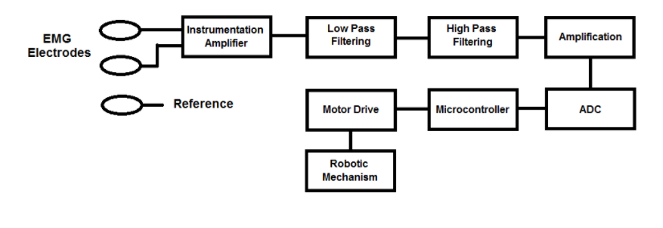

**Fig 5.2** Steps of EMG Mechanism

There are two primary motions of the human hand, flexing and extending. For flexion, electrode should be placed on Flexor Digitorum Profundus and for extension; the electrode should be placed on Extensor Digitorum Communis. As both muscles exhibit different signal patterns, therefore, a multi-channel input scheme should be employed, so that both signals are gathered independently. Both signals should be observed carefully and a suitable threshold should be set after filtering and amplification. The same procedure is to be followed in order to develop control of all the fingers of the robotic hand i.e. by placing EMG electrodes on specific muscles which control them, allowing us to classify different motions of the hand.

The amplification set for the detected EMG signals from the subject was 10,000. The EMG signal response from each of the subject’s fingers after amplification and threshold set for their control .

**5.6 Circuit design**

High Pass filter - A high pass filter is used to remove low frequency component from a particular electrical signal. A term ‘cut-off frequency’, denoted by ‘*fc*’, is the frequency below which all frequencies are eliminated. All frequencies above *fc* are carried forward. The frequency range where the filter response is ‘1’ and the signals are transmitted is known as ‘passband’ region. On the contrary, the frequency range where the filter response is ‘0’.

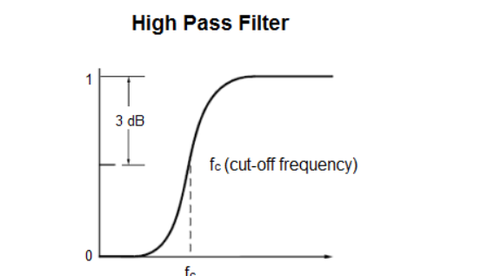

**Fig 5.3** High pass filter

Low pass filter - he concept of low pass filters is entirely opposite to that of high pass filters. In these filters, the frequencies less than the cut-off frequency are transmitted and above that are removed. The simplest low pass filter can be designed with the help of a resistor and a capacitor called as a 1st order RC circuit.

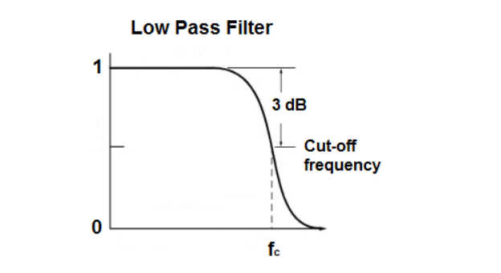

**Fig 5.4** Low pass filter

Band pass filter - the transmission of pure EMG, the high and low frequency noise should be deleted. For this purpose, only a specific band of frequency should be carried forward. This can be made possible with the help of a band pass filter.

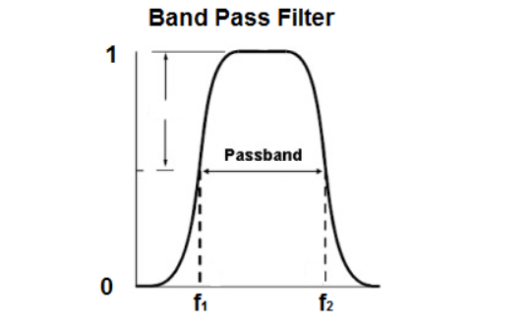

**Fig 5.5** Band pass filter

**Chapter 6**

**IMPLEMENTATION**

Implementation is the process of converting a new or revised system design into an operational one. Thus, it can be considered to be the stage in achieving a successful new system and it’s vital to assure the user confidence that the proposed new system will never cause impairs and it will be effective. The implementation is not carefully planned and controlled; it can cause chaos. Consultation and a demonstration were given to them about the working of the system. The aim of the system illustration was to identify any logical working of the system when various combinations of test data were fed. Processing accuracy and reliability checking were also made.

The first task in implementation is the implementation planning, that is deciding on methods to be adopted. The approaches of implementation are direct, parallel. In the first approach, the existing system is rejected and the new system is completely implemented. In parallel approach both existing systems and new systems will be working simultaneously.

## 

## 6.1 Modules of Project

This Section describes the different modules of the project and the pseudocode of the important functions.

* Amplification
* Filtration
* Feature Extraction
* Software Trigger

## 6.1.1 Amplification

* + - The Human brain and muscles have nerve endings called synapses which transfer electrical charges produced by the brain. The brain uses these minute electrical charges to communicate with all the parts of the human body.
    - These electrical charges/signals produced by the brain are in microvolts and since the devices and the components that we use in this project read charges between 0 to 5 volts these electrical signals have to amplified.
    - The Amplification of the electrical signals are done up to 104 or 105 times using an Instrumental Amplifier.
    - The amplified signals are then recorded as the potential difference between two points on the skin with reference to a third point.

## 6.1.2 Filtration

* + - The recorded signal frequencies are filtered using three main filters to acquire the specific signal frequency for further processing and actions.
    - The three filters used in this module are a high pass filter, a Low pass filter and a Notch filter.
    - The High pass filter filters out the signals above the cutoff point, the Low pass filter filters out signals that are below the cutoff point and the Notch filter removes a section of frequencies that emerge from other interferences such as air, alternating current, Direct current, etc. and other radio signals.
    - Filtration of the signals is very important as any form of noise can tamper with the mapping and function of all the other modules and the algorithm.

## 6.1.3 Feature Extraction

Feature extraction is a process of dimensionality reduction by which an initial set of raw data is reduced to more manageable groups for processing. Feature extraction is the name for methods that select and

combine variables into features, effectively reducing the amount of data that must be processed, while still accurately and completely describing the original data set.

The process of feature extraction is useful when you need to reduce the number of resources needed for processing without losing important or relevant information. Feature extraction can also reduce the amount of redundant data for a given analysis. Also, the reduction of the data and the machine’s efforts in building variable combinations (features) facilitate the speed of learning and generalization steps in the machine learning process.

The following processes are involved in Feature Extraction:

* **Data collection:** The datasets required for the system are collected using the EEG Headset. These are the input given to the system in a time indexed format. While collection of data the subject is trying to control any feature.
* **Data labelling:** The data collected is labelled according to the object/feature the user is trying to control.
* **Pre-processing:** While reading the data from the headset we can see external noise that occurs from electrical devices near the user, this noise has to be filtered before passing through the neural network.

## 6.1.4 Software Trigger

* The Dataset acquired after Feature Extraction is complete, is used to map each cluster that is labelled to a specific computer related action.
* When the headset that is mounted on the head detects any EEG signal produced by the brain, it records the signal and passes it to a neural network model which processes it and identifies it to associate it with the available data set.
* The model after mapping the read EEG signal triggers the respective computer action/function.

**Chapter 7**

**TESTING**

Testing can be stated as the process of verifying and validating that a product or application is bug free, meets the technical requirements as guided by its design and development and meets the user requirements effectively and efficiently with handling all the exceptional and boundary cases. Hence testing performs a very critical role for quality assurance and ensuring the reliability of the software. Errors were found and corrected by using the following testing steps and correction was recorded for future references. Thus, a series of testing was performed on the system before it was ready for implementation.

## 7.1 Test Cases

In software engineering, a test case is a specification of the inputs, execution conditions, testing procedure, and expected results that define a single test to be executed to achieve a particular software testing objective, such as to exercise a particular program path or to verify compliance with a specific requirement. In the following test plan, module testing is described.

## 7.2 Module Testing

Module testing is defined as a software testing type, which checks individual subprograms, subroutines, classes, or procedures in a program. Instead of testing the whole software program at once, module testing recommends testing the smaller building blocks of the program.

It is largely a white box oriented. The objective of doing Module testing is not to demonstrate proper functioning of the module but to demonstrate the presence of an error in the module. It allows to implement parallelism into the testing process by giving the opportunity to test multiple modules simultaneously.

**Table 7.1:** Module test case for raw input in a still state without any action

|  |  |
| --- | --- |
| Sl # Test Case: | STATE 0 |
| Name of Test: | Still State No connection to Muscle |
| Module Being Tested: | Connection Test |
| Expected Output: | Signal is at maximum value as device is not connected to hand |
| Actual Output: | Signal is at maximum value |
| Remarks: | Pass |

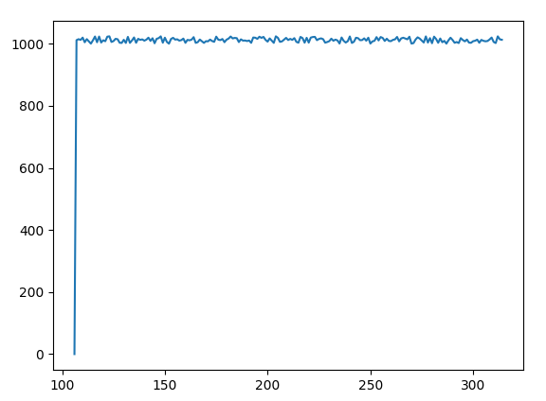

**Fig. 7.1:** Test image with some noise.

**Table 7.2:** Module test case for Eyes in closed State

|  |  |
| --- | --- |
| Sl # Test Case: | STATE 1 |
| Name of Test: | Clenching fist |
| Module Being Tested: | Subject is clenching fist. |
| Expected Output: | Consistent value without much change |
| Actual Output: | Moderate spikes and fairly consistent values seen |
| Remarks: | Pass |

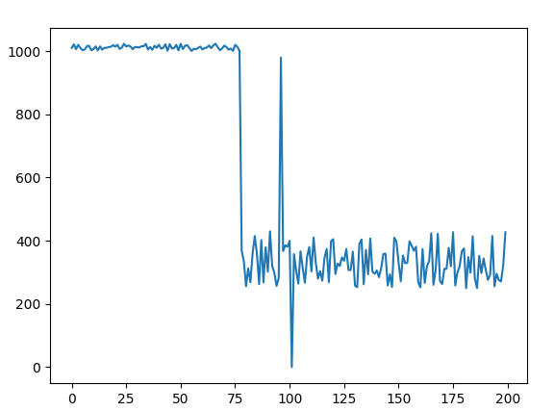

**Fig. 7.2:** Subject is clenching fist.

**Table 7.2:** Module test case for Eyes in open State

|  |  |
| --- | --- |
| Sl # Test Case: | STATE 2 |
| Name of Test: | Opening Eyes |
| Module Being Tested: | Subject is moving index and middle finger |
| Expected Output: | ADC value to be in between 400 and 600 |
| Actual Output: | ADC value roughly between 400 to 600 |
| Remarks: | Pass |

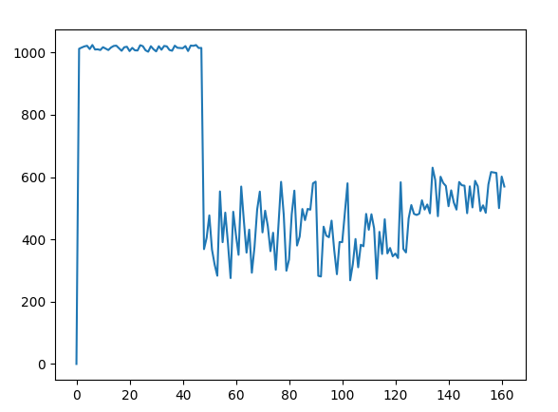

**Fig. 7.3:** Subject in rest with eyes opened.

**Chapter 8**

**RESULTS**

* We were able to successfully amplify low amplitude EMG signals.
* We were also able to successfully filter frequencies below 8 Hertz.
* We were able to read the forearm muscular EMG activity.
* We were able to detect lower levels of external noise like Wi-Fi signals, radio signals and AC fluctuation.
* We were able to classify EMG activity of the forearm based on their ADC values.
* We were able to move the mouse in the up, down, left and right directions.

**Chapter 9**

**CONCLUSION AND FUTURE SCOPE**

Thus, the project is based on manipulation of computer systems using Brain Control Interface, which uses the EEG technology to read brainwaves and use them as an input towards controlling the computer system and its functionalities, to make the day-to-day life of a disabled person or a person who works on the computer extensively easier and more efficient. In the proposed system, an end-to-end AI Neural network system will be developed using electronic encephalography and a BCI AI engines and libraries to perform automatic computer operations based on human thought processes and brain activity

## 8.1 Future Enhancement

There are two main suggestions for continued work with the system presented in this report.

1. Further development of the program, improving the game, signal processing and classification procedures and feature extensions.
2. Use the current program as a tool for larger scale tests with people, to do EEG surveys and monitoring studies.

**1) Further development and improvements of Brain Monitor**

* Implementation of automatic blink strength threshold adjustment: This would minimize the blink fault error and increase playability. The strength value varies a lot, depending on the electrode placement when the mindset is put on. This can be automatically adjusted by collecting blink strength samples, in a scenario run, from the user when blinking normally. The average value of these samples would then become the threshold.
* Enable the possibility to classify several features: One option, using the existing neural setup, is to have several neural networks trained for different recognition task and test EEG samples from the user simultaneously on all of them. Their results are then compared and the network with highest probability wins. Another option is to design a new neural network architecture with all the features wanted in the system represented in the output layer. One output node per feature.
* Add P300 recognition, to assist in classification verification: For example, if the user blinks when playing the snake game to signal” sample mode”, detecting the P300 signal could verify that this is the wanted move. Instead of looking at band powers to find the P300, the raw incoming EEG data could be spatially analyzed by an algorithm that searches and verifies a peak in the incoming sample.
* Interface the Brain Monitor program with existing games: There are many open-source games available, that could be interesting to connect with the EEG equipment. The advantage is that a lot of work is already done, like the graphical display and gameplay, so the focus can remain on what and how the EEG function should be. This is further described in the” ideas for the future” section.
* Interface the Brain Monitor program with hardware: There exists a library for simple communication with a microcontroller. The same microcontroller that was used in the PlayStation project could be used to integrate it with hardware and make physical objects move, for example.

**2) Brain Monitor as a tool**

Here are some suggestions of how to utilize the current system as it is:

* More verifications: Run tests that run over a period of time, to see if it is possible to improve brain wave control skills using the system. The goal and motivation should be to annihilate the need for the eye states, and rely on mental efforts only.
* Explore classification possibilities: Define new experiments to find if there are other mental tasks that are usable for classification in the system. This could be rotation, mental speech or specific memory retrieval.
* Explore placement possibilities: Disassemble, if possible, the arm on the mindset that holds the electrode and find alternative placement for it. Conduct test to see if those placements are better suited for solving the classification tasks at hand. The inconvenience is that there can be no hair between the electrode and scalp.

**Chapter 10**

# REFERENCES

[1] Brain-computer interface (BCI) evaluation in people with amyotrophic lateral sclerosis.‖ McCance LM, Sellers EW, McFarland DJ, Mak JN, Carmack CS, Zeitlin D, Wolpaw JR, Vaughan TM.

[2] Brain Computer Interface-Controlling Devices Utilizing The Alpha Brain Waves | Rohan Hundia

[3] Classification of EEG Signals in Brain-Computer Interface System | Erik Andreas Larsen, Alf Inge Wang

[4] A General Framework for Brain-computer Interface Design | Steven G . Mason, Gary E . Birch

[5] Brain-Computer Interface Systems: Progress and Prospects | Brendan Z Allison, Elizabeth Winter Wolpaw, Jonathan R Wolpaw.

[6] Rig Das, Emanuele Maiorana, Patrizio Campisi, “Motor Imagery for EEG Biometrics Using Convolutional Neural Network”

[7] Steven G. Mason, Member, IEEE, and Gary E. Birch, Member, IEEE, “A General Framework for Brain–Computer Interface Design”

[8] Rohan Hundia, “Brain Computer InterfaceControlling Devices Utilizing the Alpha Brain Waves”

[9] Honglak Lee, Yan Largman, Peter Pham, Andrew Y. Ng, “Unsupervised feature learning for audio classification using convolutional deep belief networks”

[10] A.N. Pavlova, A. E. Runnovaa, V. A. Maksimenkoa, O. N. Pavlovab, D. S. Grishinab, and A. E. Hramov, “Recognizing Arm Motions by Fluctuation Analysis of EEG Signals”

[11] T. Mulder, “Motor imagery and action observation: cognitive tools for rehabilitation,”

[12] D. Xiao and J. Hu, “Identification of motor imagery EEG signal”